ELEKTRO- PHYSICAL REFORM OF THE WATER

http://www.aqalex.sk/
efuv 0xxh

Assembling direction

Electronic softener of the water consist of tuning electronic generator and electromagnetic reel. Electromagnetic reel coil in the middle of piping according to decision from non-magnetic material about length min. 40cm (defiance. on plastic piping, alternatively hose) reel consist of thirteen thread and is fixation removal tape. Electronic generator locate to distance around. 20 till 30 cm from reel.

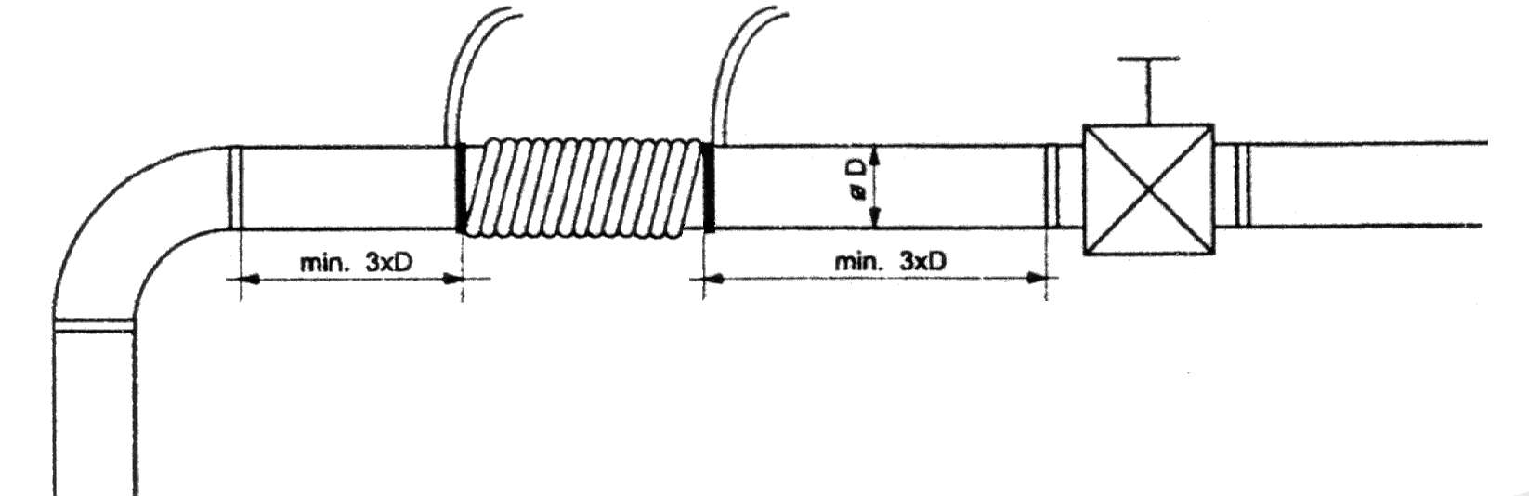
Reel must be set so, with the view of she was from metal often piping and armature alternatively marrowbone away minimum treble diameter of piping.

Assembling advance :
According to listed criteria designate at first position reel on piping. Then fasten signal generator on piping, alternatively wall, 20 till 30 cm from spoil, where coil reel. Spool
13 thread performance driver on piping. Against release canned both end of reel application removal tape. Driver at need shorten and on his end fasten connector, which throw to socket on generator. After shot connector stop flicker check light performance ring, which us guarantee right activity generator. That is henceforward indication green check light ascension signal.

Example installation in practice -
