ELEKTRO- PHYSICAL REFORM OF THE WATER

http://www.aqalex.sk/
efuv MAX I.

Assembling direction

Electronic softener water consist of tuning electronic generator and electromagnetic reel. Electromagnetic reel coil in the middle of piping according to decision from non-magnetic material. Reel consist of thirteen thread and is fixation removal tape.

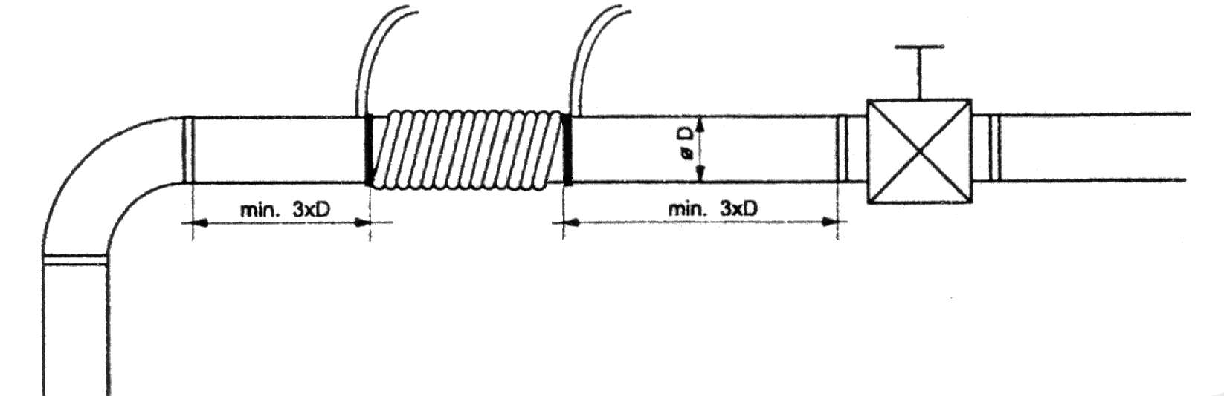
Reel must be set so, with the view of she was from armature, alternatively marrowbone away minimum treble diameter piping.

Assembling advance :
According to listed criterion designate at first position reel on piping. Then fasten lonely instrument allowing on wall, 20 till 100 cm from spoil, where coil reel. Spool 13 thread performance driver on piping. Against release canned both end of reel application removal tape. Both end at need shorten and conversion their through cable passage toward apparatus terminal. Through the same passage too many toward terminal too duo-driver by your leave feeding (low) intensity. Coil fasten to terminal designation signal out, driving voltage on clamp +12V (positive pole), Gnd (negative pole). Toward instrument is standard delivery feeding constant source 12V/300mA. On twin-wire line is negative pole marked oblong red strap. Producer belie behind damage instrument cause connecting non-qualitative feeding source. Cable passage we recommend in conclusion installation tamp against damp defiance. silicone putty.

