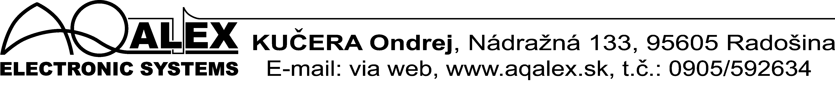

Service and direction on installation "S" modulate

for classroom MAX.

Internal by your leave modules for reform classes MAX raise effeciency modification too near problems steel piping. Modules no possible absolutely deliver, alternatively their install to instrument, which he bore therewith downoloadable still near production. Increase effeciency in consist second-hand clocked electrostatic windy included with electromagnetic. Look like executive part are using two reel by your leave segregation driver, (which fashion instrument) installed on piping after both side conclusion- electromagnetic reel. End electrostatic vessel they are unconnected and create ring "no-load". Style installation on piping they are identical, look like at lonely electromagnetic reel therewith, that distance distance between marrowbone and reel (3x diameter) is meditation from altogether external electrostatic coils. Every "S" modulus is furnished red flashing signal check light step on front panel instrument. Producer guard synchronisation "S" modulus by your leave function electronic, bunk every "S" modulus is specific for given type instrument.
In the picture is visible way installation reel on piping. Outlet "M" magnetic reel (in Wednesday) join on magnetic ascent instrument, after both side coil two redundand reel, those unconnected end let soft
exceed through fixative tape. Both internal end static reel "S1 and S2" join on static ascent instrument. Orientation thread at static vessel must be different. Distance between reel they are cca 1x diameter piping. Distance vessel from marrowbone, armature and other often must be minimum 3x diameter piping.

Pic. Installation reel on piping.
